Practical Activity 5

fikile.goodness@womentehsters.org

Fikile Goodness Mathobela

1 Go to server manager

2 On the navigating bar select Tool. Then select active directory user and computer

3 On your left panel , right click on user, go to new and select organation unit and add CarMax

4 right click on CarMax, go to new and select organisation unit and add Headquarters

5 repeat step 4 and add Sale1 and Sale2

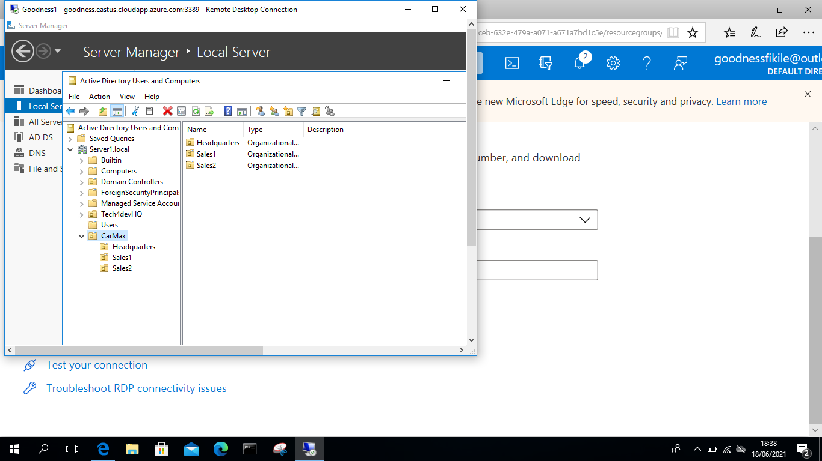

6 add groups under each unit.

-right click, new select group

7 repeat step 6 for each unit naming them accordingly

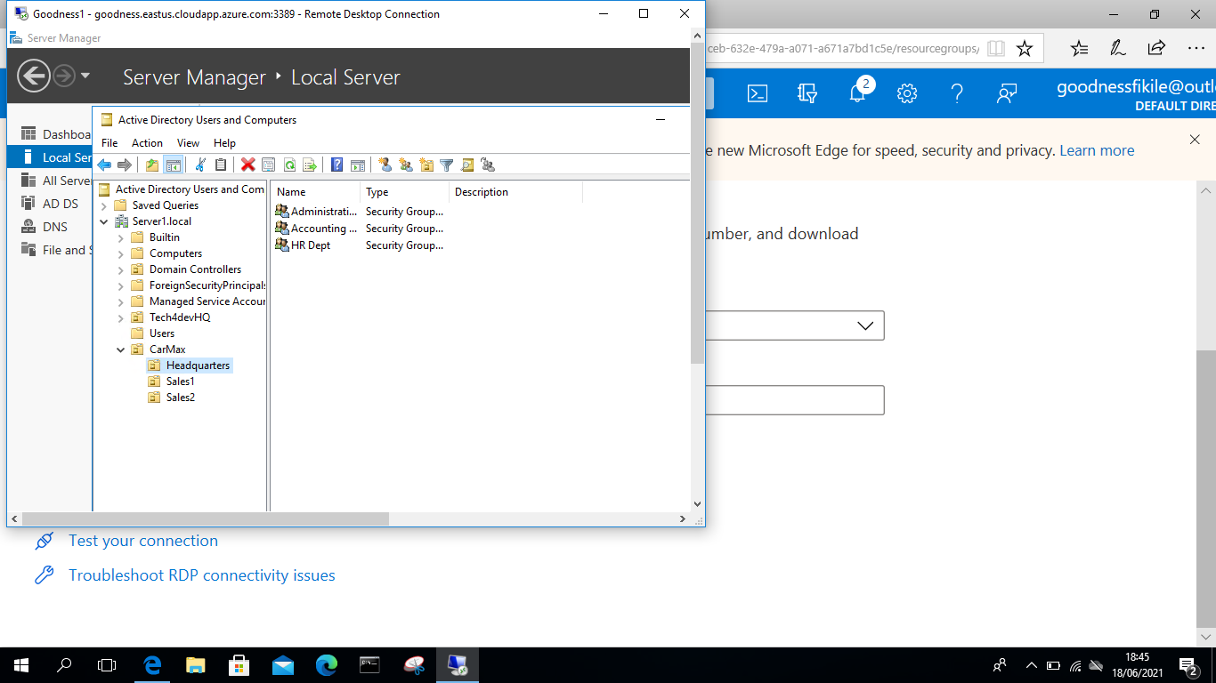

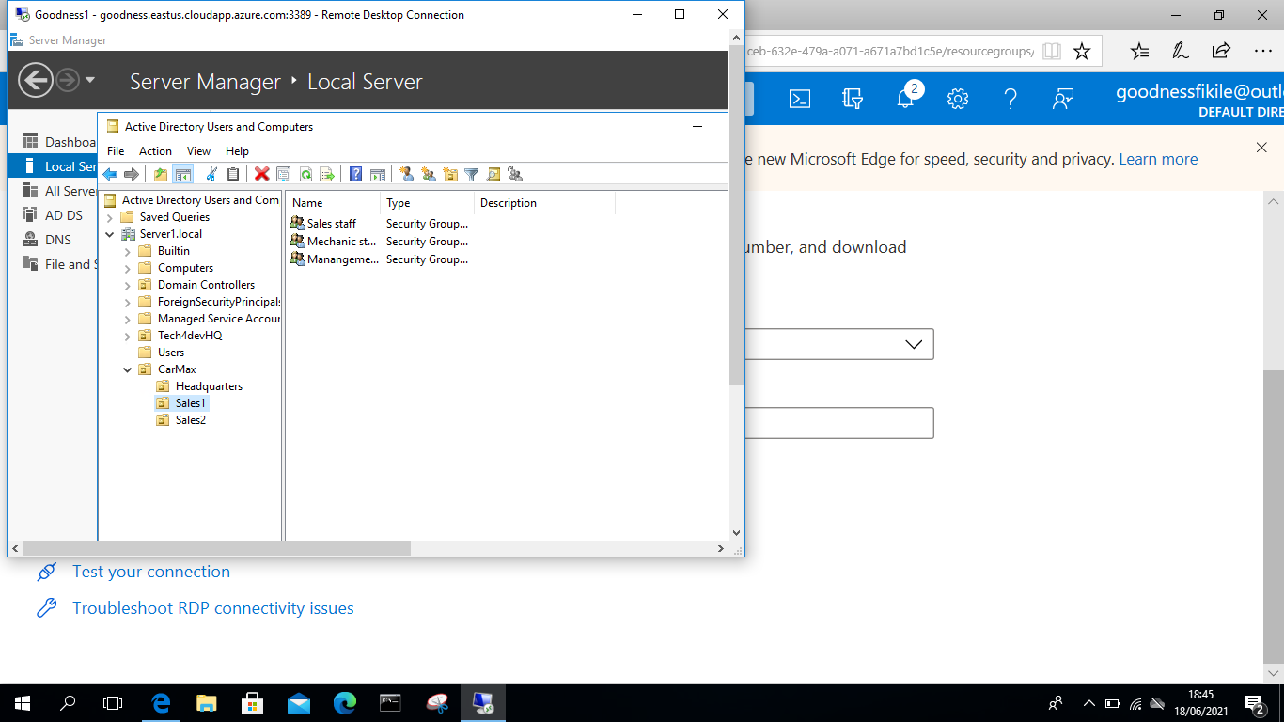

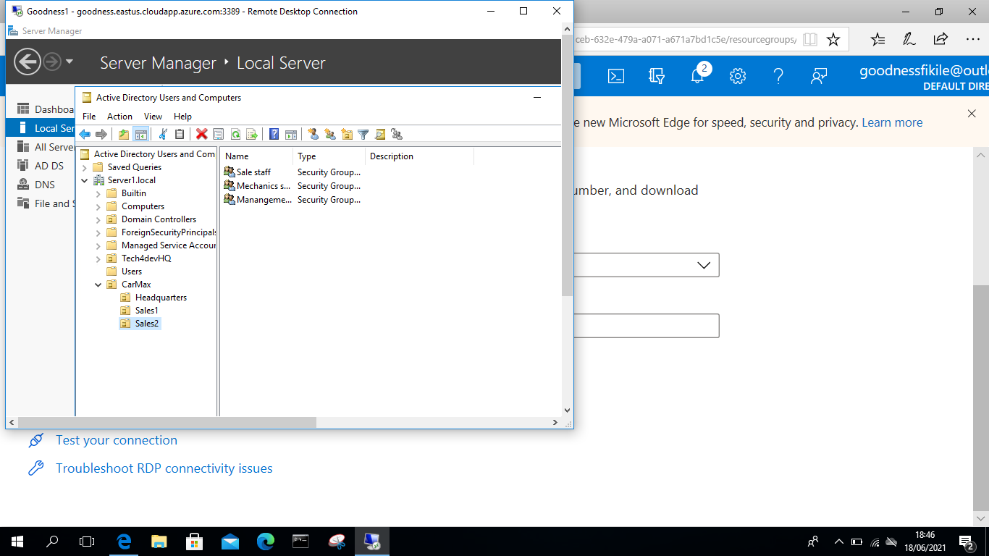

Under each unit add users

1 go on the first unit, right click , go to new and select user

2 add user name and password and enter

3 repeat step 2 for all units, adding users for each

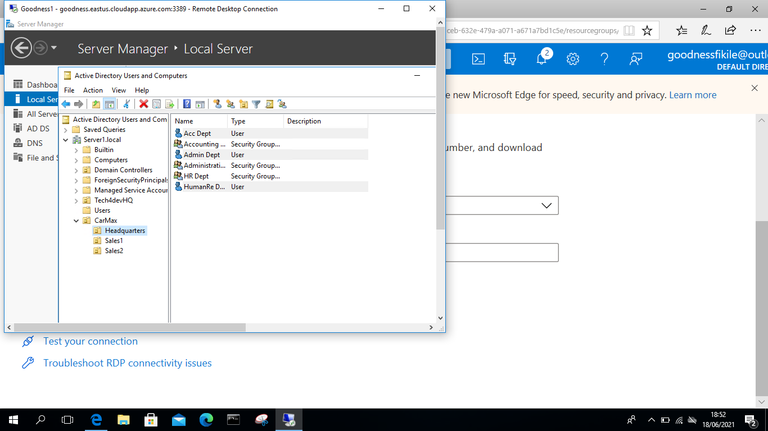

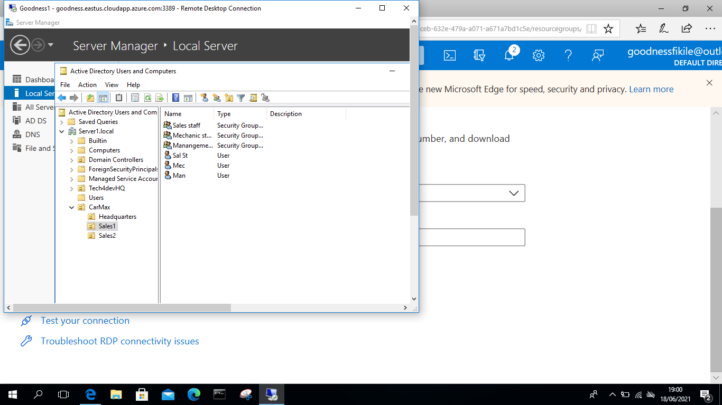

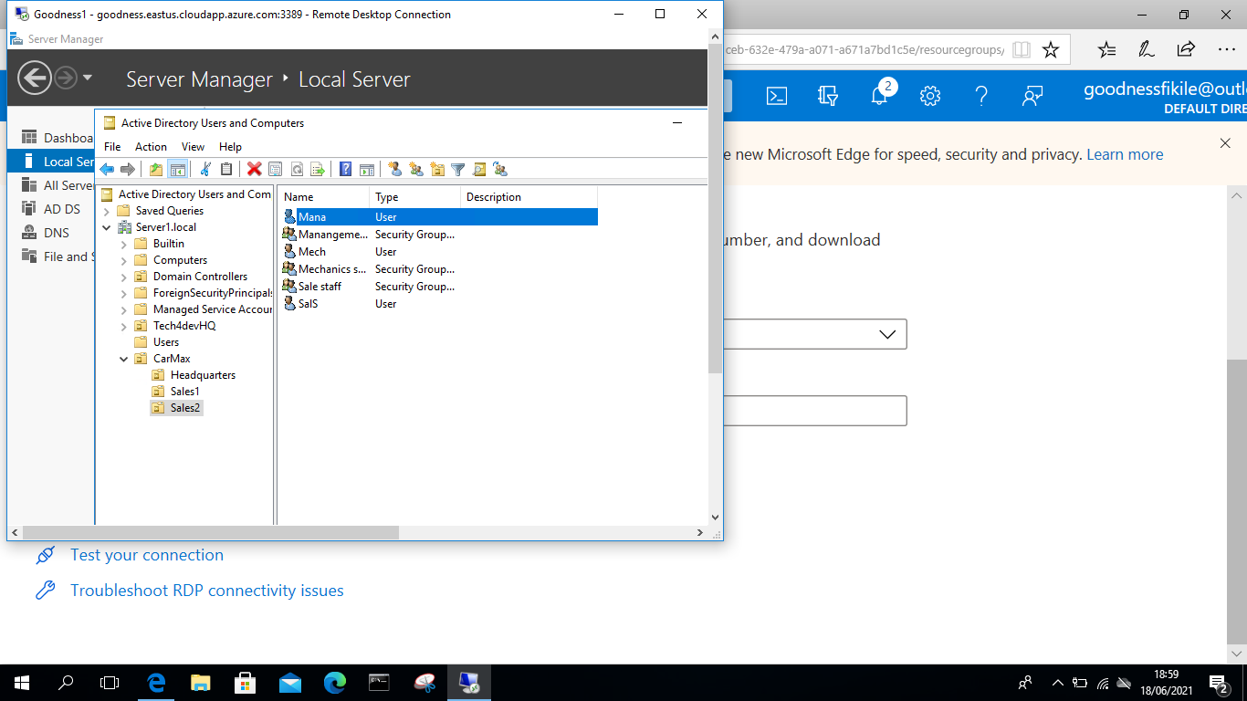

Now add each user to their respective groups

1 Click on the unit, go to properties

2 select members of

3 add member, type the name of user, click check name

4 apply and ok

To move a user from one group to another

1 go to the unit you want to move (promote) the user to

2 right click and select property

3 select members of and add new member to the existing member

4 type the user name and click name check

5 apply and ok

6 go back to the unit which the new user if from

7 select the unit, right click >properties

8 select member of and remove the user

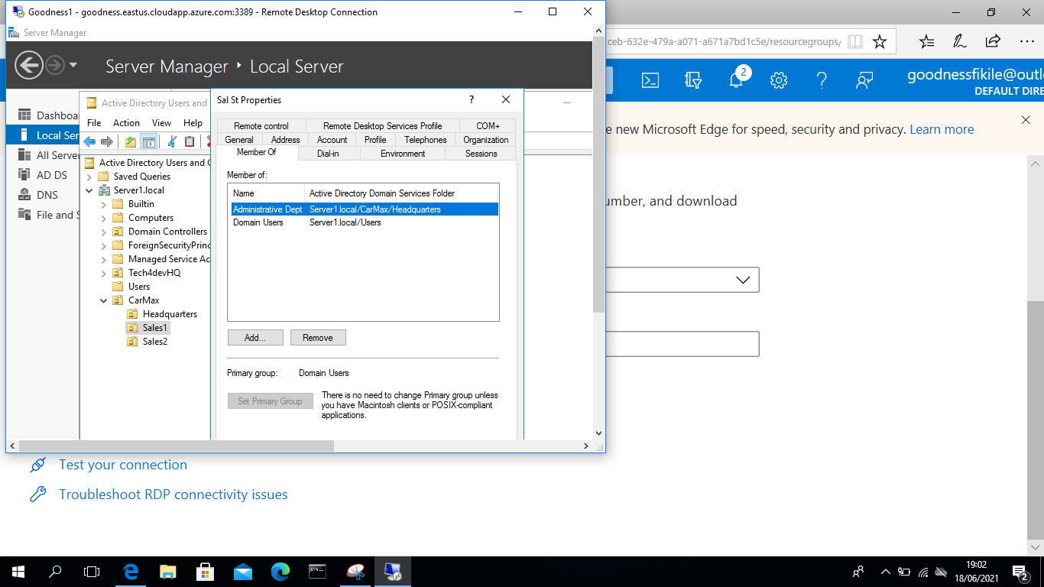

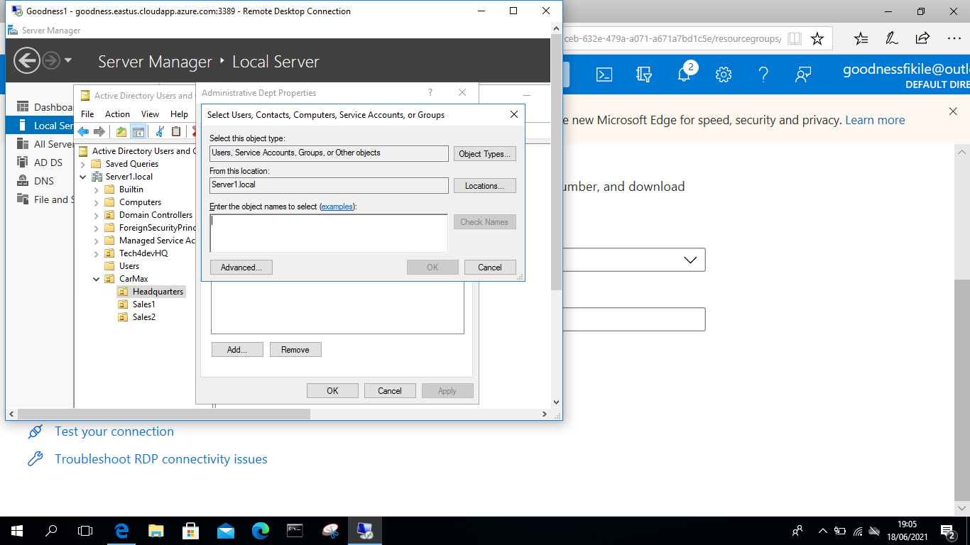

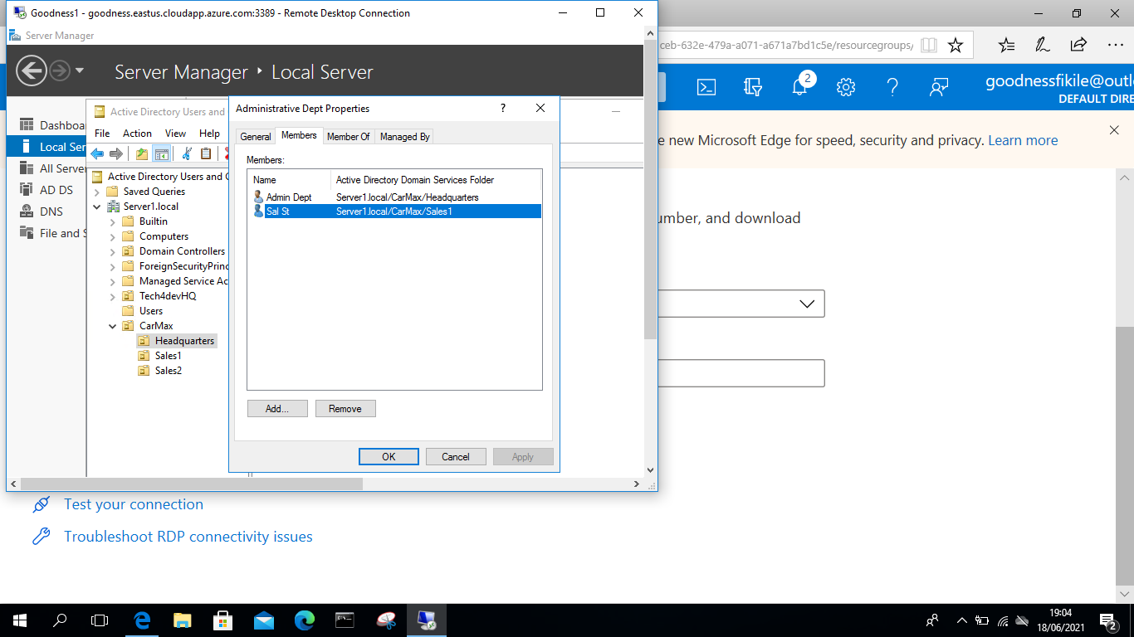

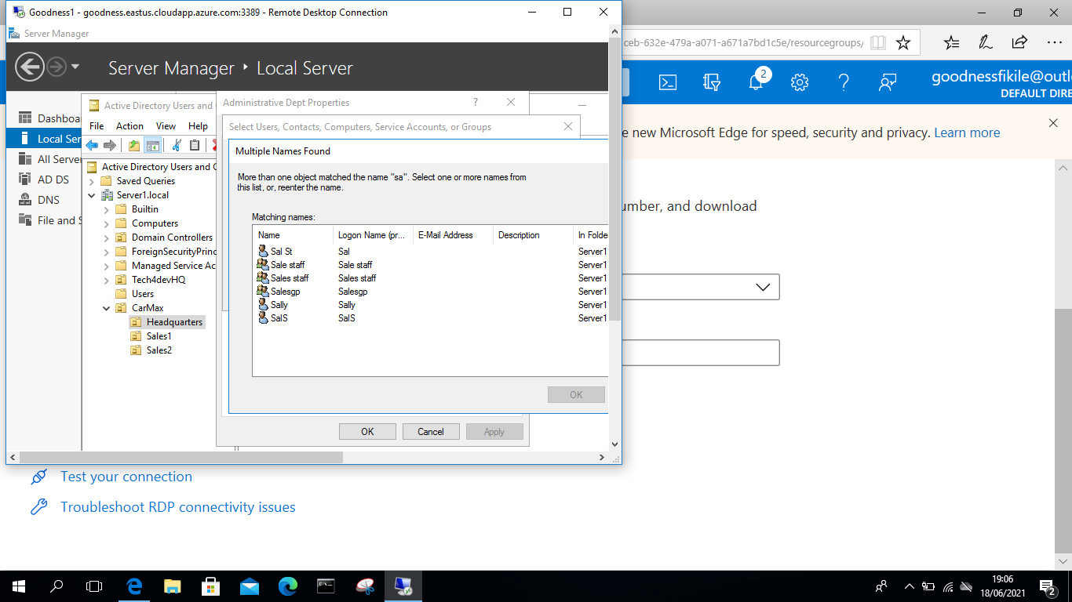

To inactivate a user for a while

1 go to the user that you want to inactivate

2 right click and select deactivate

3 a popup will appear written deactivated, press ok

4 right click the same user >properties>account> account option ,scroll down and you will see that the account is deactivated

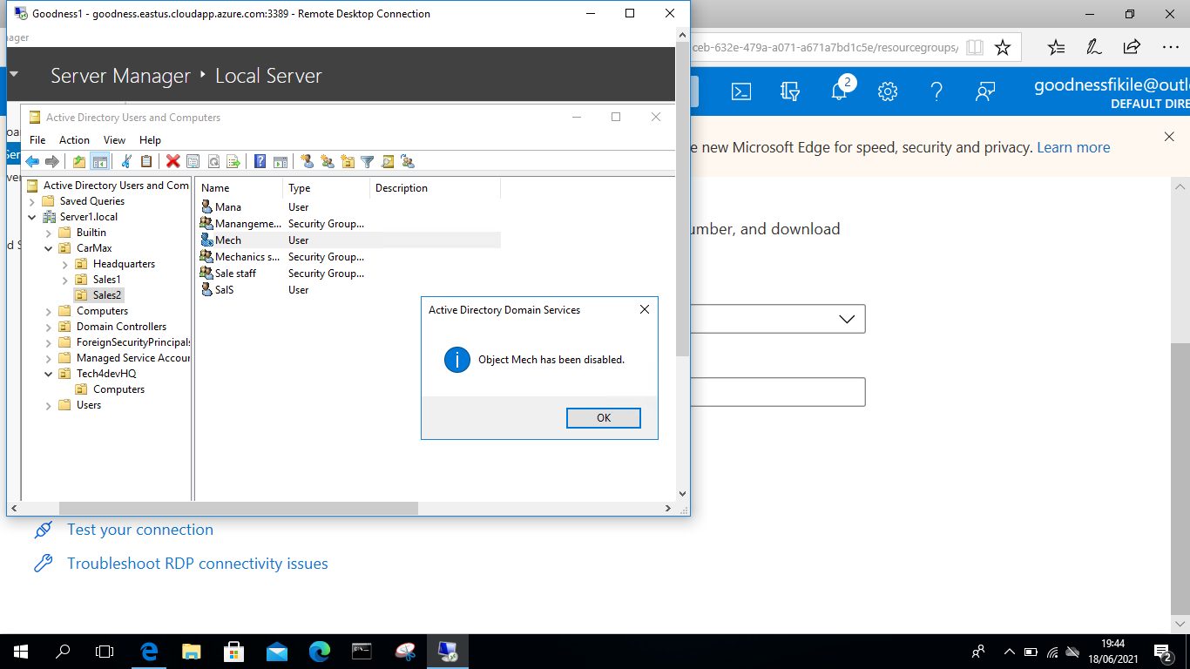

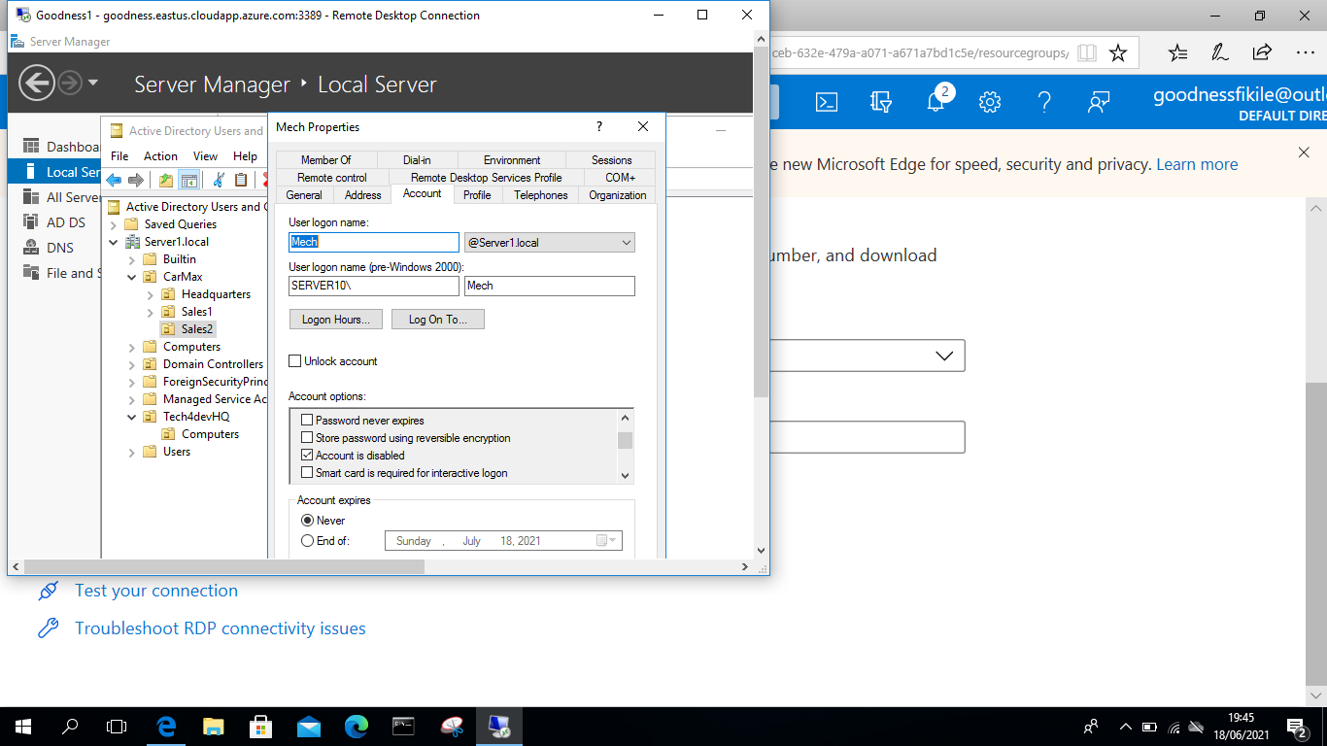

Adding a computer policy

1 go to navigating bar and select tool> group policy management>domain server, right click and select create GPM>add name, ok. Select settings, right click and edit

2 computer configuration>policies>windows setting>security setting>local policies>security options

3 select: interactive logon: machine inactivity limit. Set the time limit per second (60 second \* 3 for 3minutes = 180 seconds) apply and ok.

